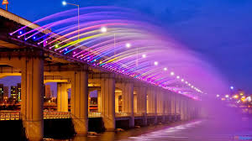**Banpo Bridge**

Banpo Bridge (Korean: 반포 대교; Hanja: 盤 浦 大橋) is the main bridge in downtown Seoul spanning through Han River, South Korea, connecting Seocho and Yongsan districts. The bridge is located on Jamsu Bridge, forming the upper half of the two-story bridge. Banpo Bridge is the first two-story tree built in Korea. During the heavy rainy season, the Jamsu bridge is designed to be submerged when river levels rise, such as drainage lines. The fishing line was built as a girder bridge and was completed in 1982.

**Rainbow Moon Fountain**

Rainbow Moon Fountain (Korean: 달빛 무지개 분수) is the bridge with the longest fountain in the world [6] It is recorded in the Guinness Book of Records with nearly 10,000 LEDs with fountains running along the sides. The bridge body is 1,140m long, firing 190 tons of water every minute. Installed in September 2009 on Banpo Bridge, former Seoul Mayor Oh Se-hoon announced that the bridge would continue to beautify the city and showcase Seoul's eco-friendly ecosystem, as water is pumped. directly from duplex and constantly recycle. The bridge has 38 pumps and 380 nozzles on either side, using 190 tons of water per minute from less than 20 meters of the river, and firing 43 meters away horizontally.

It was completed in 2010 and opened in 2011. Employing 10,000 people, construction took four years and cost about $8.5 billion. The Danyang–Kunshan Grand Bridge currently holds the Guinness World Record for the longest bridge in the world in any category as of June 2011.